Test Case: tc001_SPX_Dev5_Crear_Requisicion_Spot_Tipo_Cobro_CC
Step 1 - Enter username and password and click to button Enter : Credentials Entered
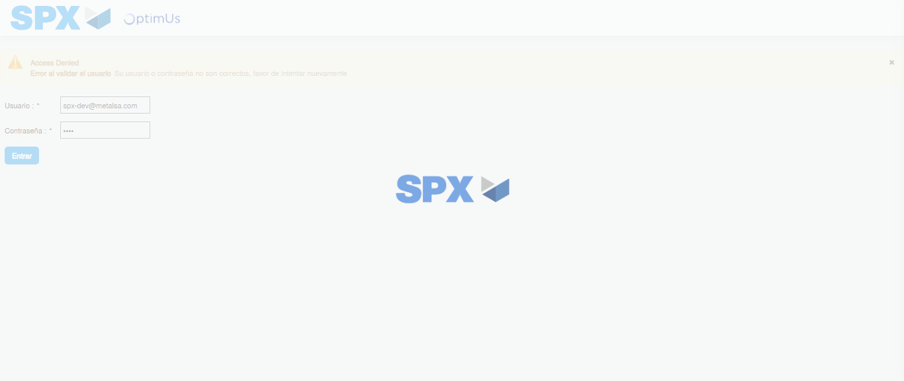Image file-name: QC_Testing-tc001_SPX_Dev5_Crear_Requisicion_Spot_Tipo_Cobro_CC-1783984507753

Step 2 - Select to UEN and Access to Spot Buy Requisitions : UEN Correctly selected and Correct access
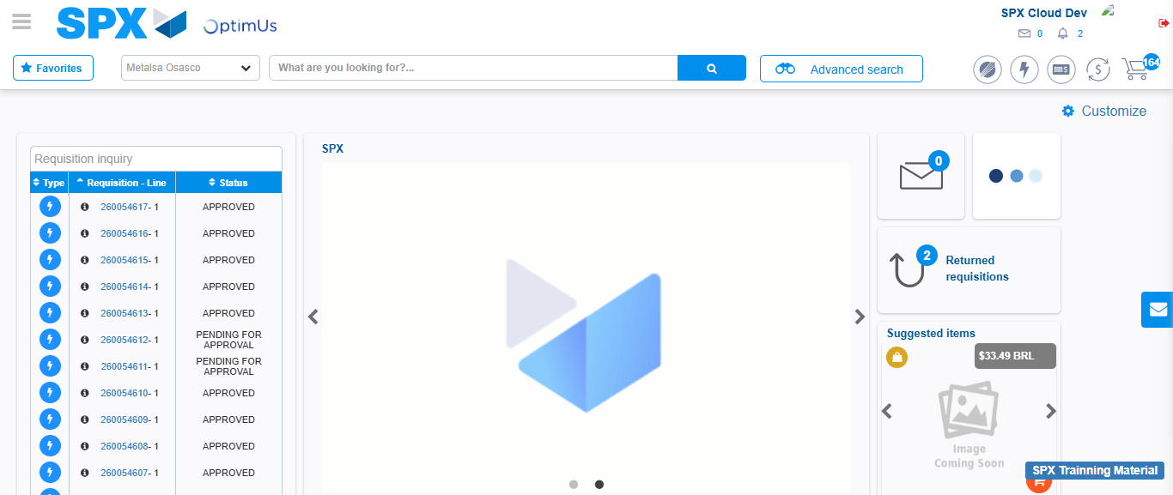Image file-name: QC_Testing-tc001_SPX_Dev5_Crear_Requisicion_Spot_Tipo_Cobro_CC-1783984534677

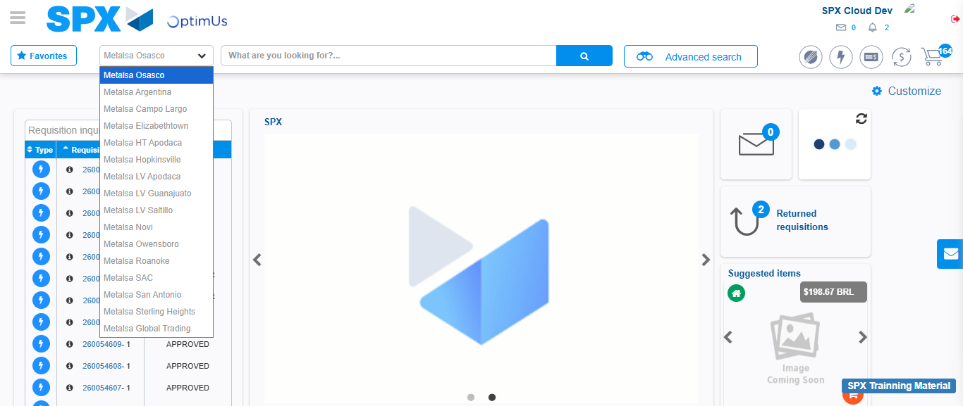Image file-name: QC_Testing-tc001_SPX_Dev5_Crear_Requisicion_Spot_Tipo_Cobro_CC-1783984537480

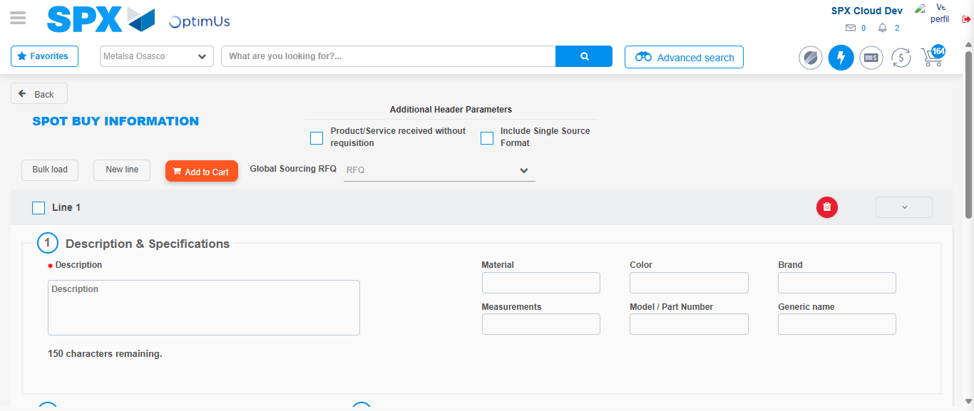Image file-name: QC_Testing-tc001_SPX_Dev5_Crear_Requisicion_Spot_Tipo_Cobro_CC-1783984558713

Step 3 - Data Capture Spot Buy Requisition : Data captured correctly
Image file-name: QC_Testing-tc001_SPX_Dev5_Crear_Requisicion_Spot_Tipo_Cobro_CC-1783984558972

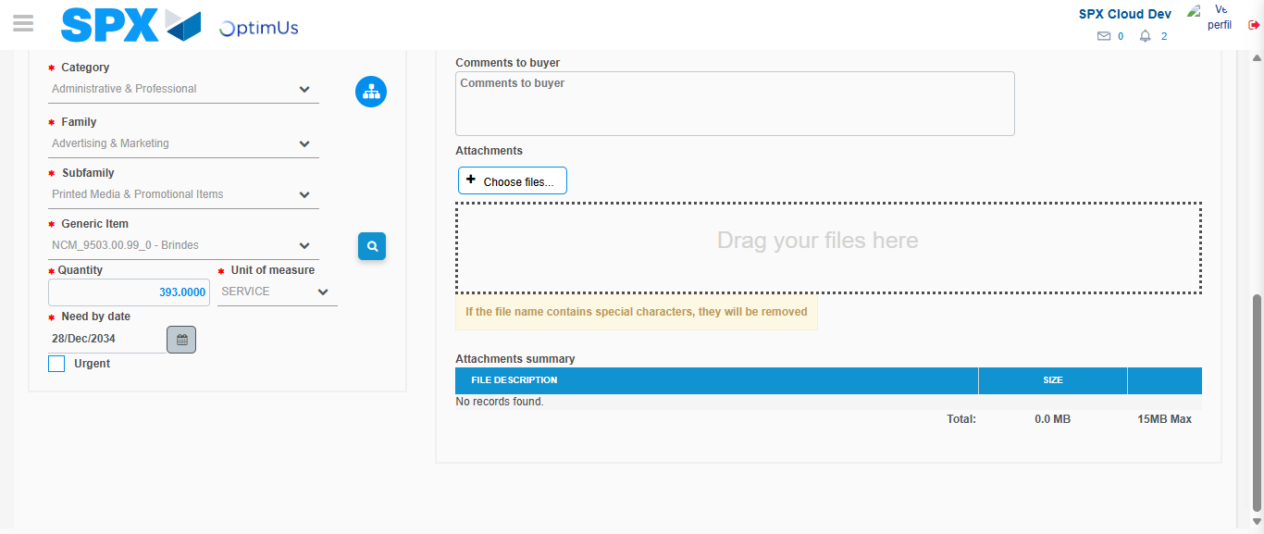Image file-name: QC_Testing-tc001_SPX_Dev5_Crear_Requisicion_Spot_Tipo_Cobro_CC-1783984571395

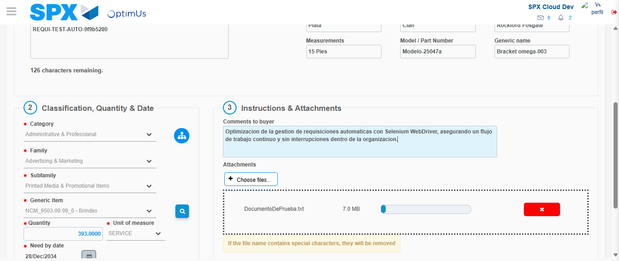Image file-name: QC_Testing-tc001_SPX_Dev5_Crear_Requisicion_Spot_Tipo_Cobro_CC-1783984572368

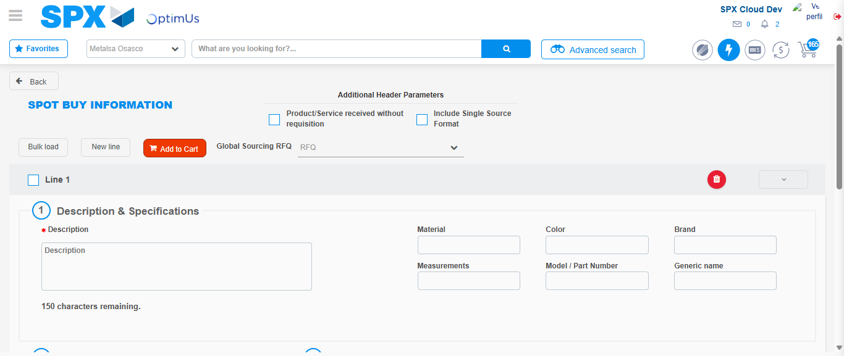Image file-name: QC_Testing-tc001_SPX_Dev5_Crear_Requisicion_Spot_Tipo_Cobro_CC-1783984585264

Step 7 - Return to Main Page SPX : Return to Main Page SPX
Image file-name: QC_Testing-tc001_SPX_Dev5_Crear_Requisicion_Spot_Tipo_Cobro_CC-1783984534677

Image file-name: QC_Testing-tc001_SPX_Dev5_Crear_Requisicion_Spot_Tipo_Cobro_CC-1783984537480

Image file-name: QC_Testing-tc001_SPX_Dev5_Crear_Requisicion_Spot_Tipo_Cobro_CC-1783984558713

Image file-name: QC_Testing-tc001_SPX_Dev5_Crear_Requisicion_Spot_Tipo_Cobro_CC-1783984587510

Image file-name: QC_Testing-tc001_SPX_Dev5_Crear_Requisicion_Spot_Tipo_Cobro_CC-1783984587709

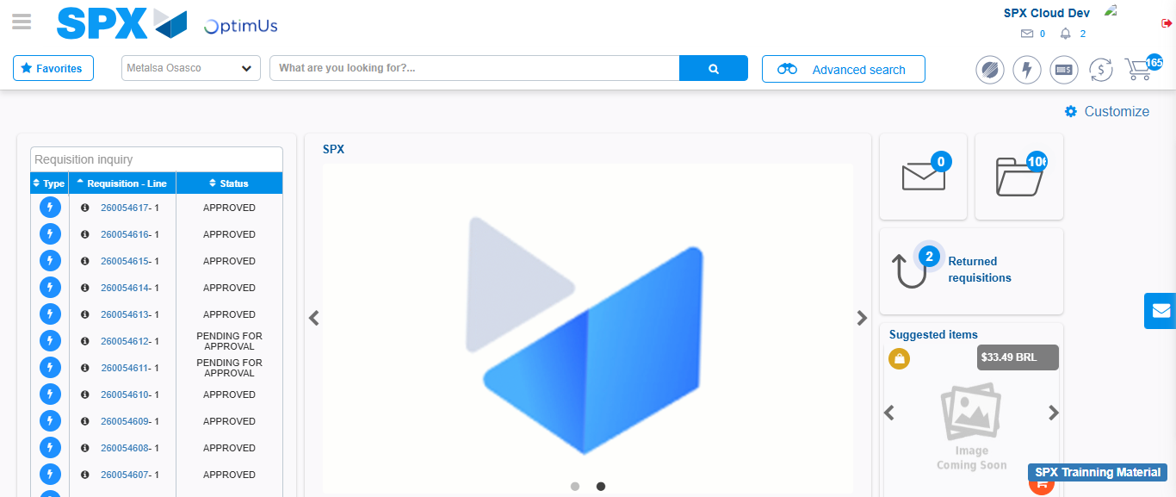Image file-name: QC_Testing-tc001_SPX_Dev5_Crear_Requisicion_Spot_Tipo_Cobro_CC-1783984609030

Step 8 - Log Out : Log Out SPX
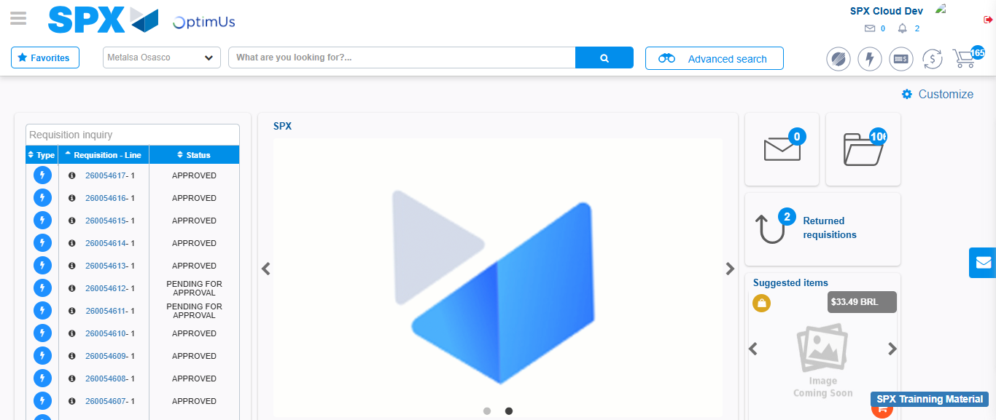Image file-name: QC_Testing-tc001_SPX_Dev5_Crear_Requisicion_Spot_Tipo_Cobro_CC-1783984609425

